

OBJECTIVE OF THE GAME:
Compete with other players by dressing up mannequins with cards in ascending order. However, you are NOT allowed to look at your own cards, so players will need to request hints to avoid errors and achieve success while remembering all the information collected.

WHAT YOU WILL NEED TO PLAY:
Dress Code is played with 2 to 4 players and a deck of 50 Dress Code cards, 16 -32 Blue tokens, 6 - 12 Red tokens, and a box (or divider) per player. (The number of tokens depends on the number of players. For example: If you’re only playing with only 2 players, then you will need 16 Blue tokens and 6 Red tokens. Also, a mediator is recommended to prevent either player from sabotaging the game with false information.)
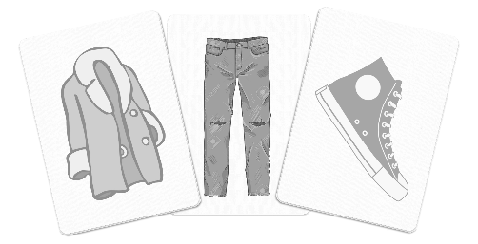

CLOTHING VALUES (Low to High):
Hat-Coat-Shirt-Pants-Shoes (1-2-3-4-5)
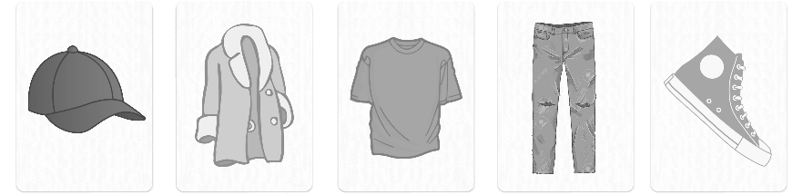

SETTING UP THE GAME:
Place 8 blue tokens in a box for each player and 3 red tokens outside each box per player. Then shuffle the Dress Code cards into a faced down deck. Now deal each player 4 cards (if playing with 4 players) or 5 (if playing with 2 or 3 players). THE PLAYERS CANNOT LOOK AT THEIR OWN CARDS! They will turn their hand around so everyone else but them can see their cards. The player wearing the most colorful clothing goes first and will be continued in a clockwise rotation.
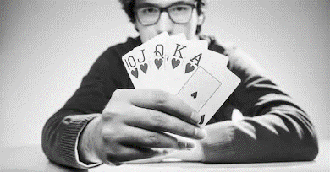

THE GAME:
Each player has 3 actions they are allowed to perform during their turn:
- Requesting specific information – The current player takes a blue token from their box and places it outside the box with their red tokens. After completing this task, the player can request a piece of information about their cards from their opponent(s). However, this action can only be performed if a blue token is outside their box. And the information requested is limited to either the color or the clothing of their card, so the player requesting information needs to decide on what hints they need. Also, the player giving information needs to give out complete information, for example: “You have a green card right here”, and… “You have two shirt cards right there and there”.

- Discarding a card – The current player returns a blue token to their box. After completing this task, that player discards a card from their hand into a separate discard pile left face up. Then they will take a new card from the pickup pile without looking at it. However, this action cannot be performed if all the blue tokens are inside their box.

- Playing a card – The current player takes a card from their hand and will place it down face-up in front of them. This action will have two outcomes, the first resulting in the beginning or completion of an outfit for their mannequins. The second outcome involves the card failing to start or complete an outfit, resulting in a red token being added into their box. If there are still red tokens remaining outside the box, then the game continues, and the player will take a new card from the pickup pile without looking at it.

OUTFITS:
Five outfits must be assembled! Each outfit requires one distinct color of clothing and needs to be placed in ascending order by the clothing’s values. (Start with a Hat, then a Coat, followed by a Shirt, then Pants, and finally Shoes.) When a player completes a mannequin’s outfit, they can put a blue token back into their box.
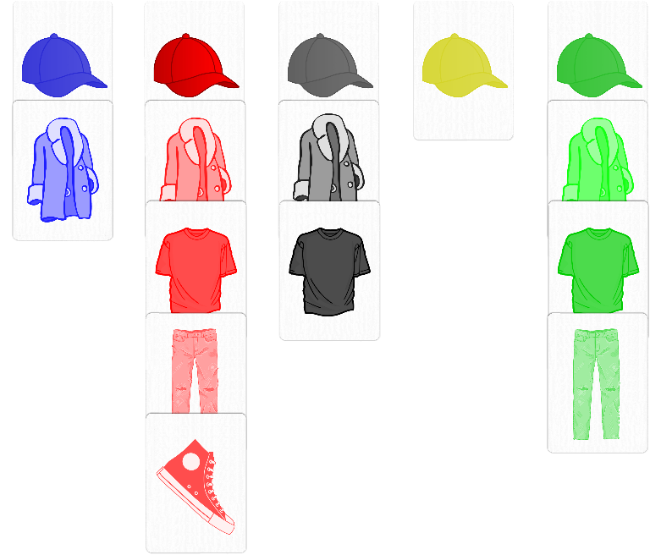

WINNING. LOSING. ELIMINATING:
There are 3 scenarios that will end the game to determine a winner:
- Red Tokens – A player will be eliminated if all their red tokens are placed in their box. The game will end immediately if only one player has a red token(s) remaining outside their box. As a result, that player would win.
- The Last Card – The game will end if the pickup pile runs out, but each player will have one more turn remaining. (They cannot draw any more cards from the deck because its empty.) After that final turn, the winner will be determined by the number of clothes they currently have on their mannequin(s).
- Perfect Wardrobe – The game will end immediately if a player completes all five outfits before the deck runs out. That player will win as a result.

SCORING:
There is no scoring in this game:

